


newsletter
  - 2023-24 Issue 11
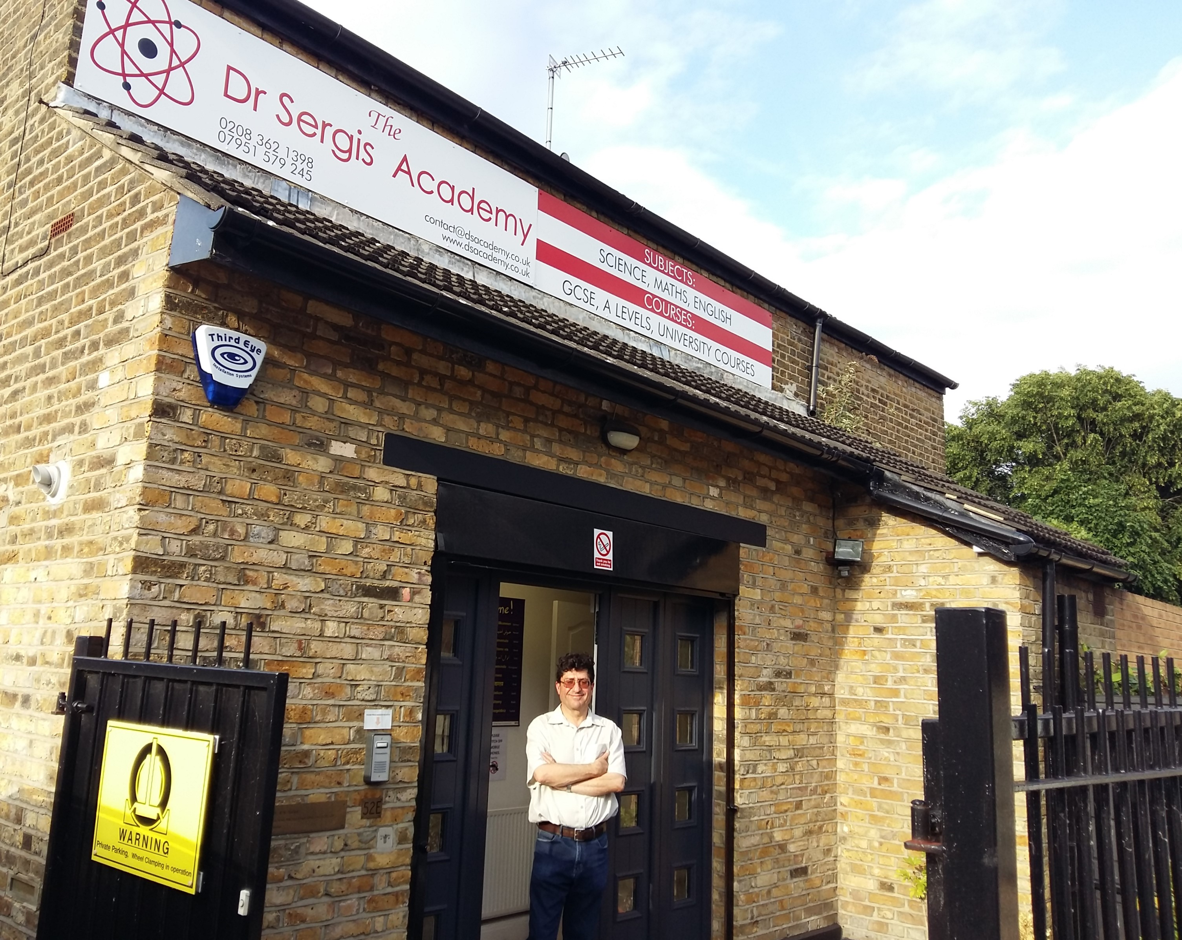

IN THIS ISSUE….
- An introduction from the Director, Dr Sergis! Page 1
- What’s New? Page 2
- An Inspirational Figure: Betrand A.W Russell Page 3
- Dr Sergis and Einstein at the Metro Bank Event Page 4
- Work Experience at the Academy Page 5
- Who was Apollonius of Perga? Page 5
- The Dr Sergis Academy Celebrates 10 Years! Page 6
- Owls in the Ancient World Page 7
- Plato’s Academy Page 7
- The Dr Sergis Academy Returns to the Annual Laboratory Exhibition Page 8
- Heart Experiment in the Academy Laboratory Page 8
- The Academy Attends a Greek Night in Sue’s Name Page 9
- Catherine the Great of Russia and Education Reform Page 10
- Picture Perfect Page 11
- Puzzle Page Page 12


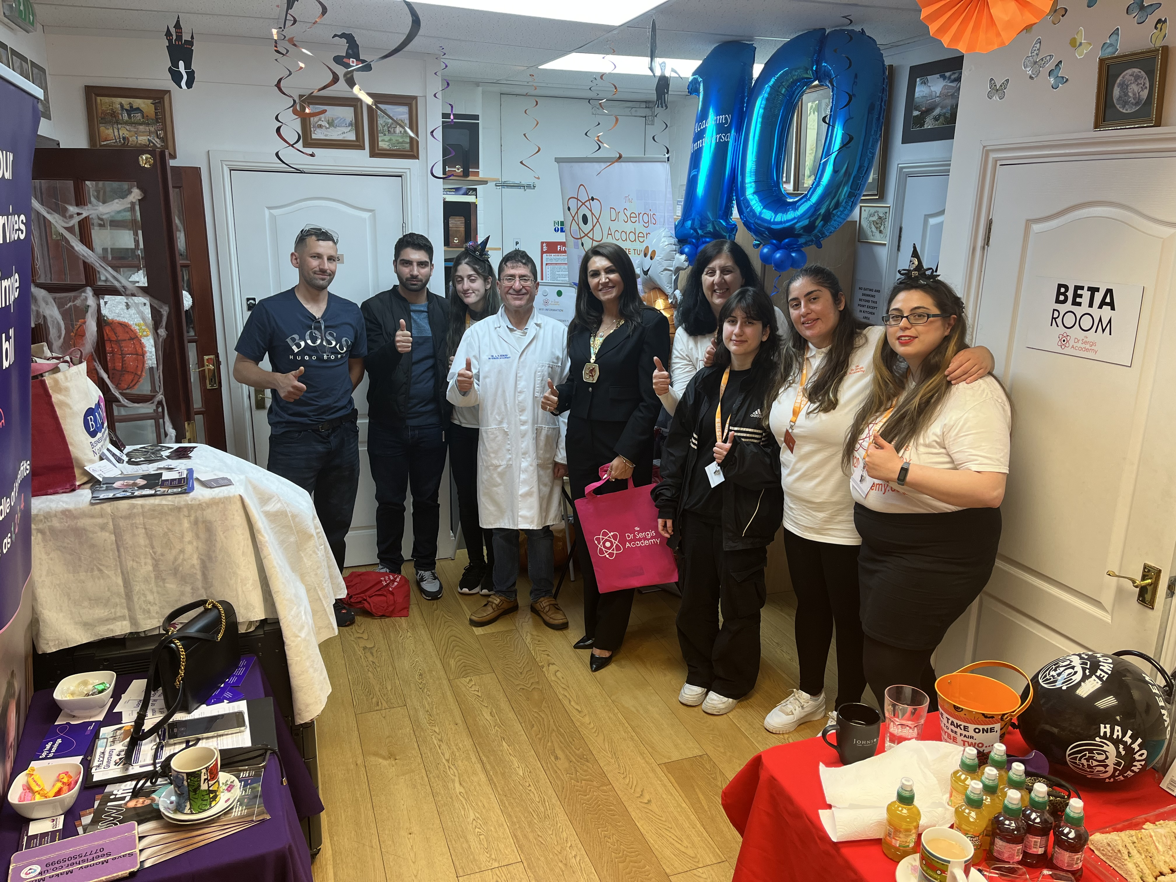


‘Education is Our Motivation and Learning is Your Inspiration’.

An Introduction from the director, Dr sergis
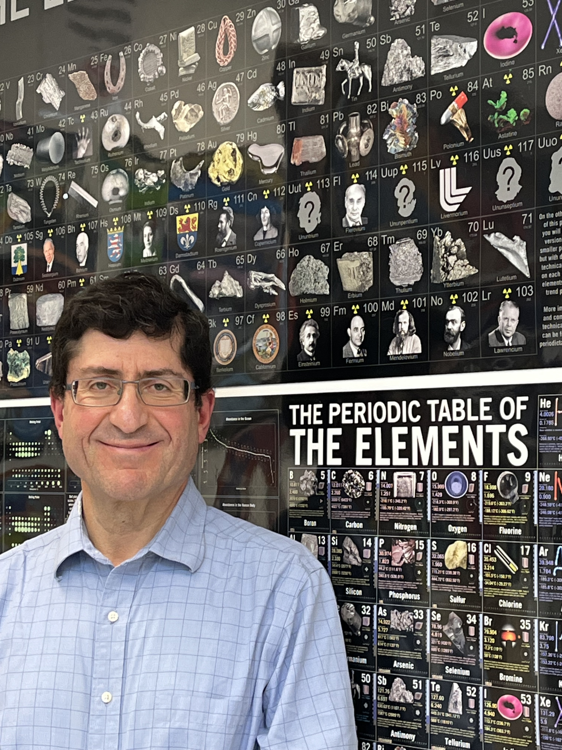
Dr Sergis in front of our very large periodic table!
Contact Us
The Dr Sergis Academy
52E Southbury Road, Enfield, Middlesex, EN1 1YB
Tel: 02083621398
contact@dsacademy.co.uk
www.dsacademy.co.uk
As an educator at my Academy, I endeavour to inspire students to learn to think logically and question everything, which is the mark of a truly well-educated person. I encourage students to apply the Scientific Method in understanding their world in the same way a good scientist or thinker does in attempting to understand the natural world. I advise all students when studying any matter or subject to ask themselves only what the facts are, and how they stand up to solid evidence. In this way, they learn to critically evaluate the subjects they study and use deductive reasoning to answer questions. This gives them a better understanding of their subjects and they achieve better results in exams than simply memorising ideas as they usually fo in schools.
Consequently, I believe any field of knowledge becomes far more interesting when studied deeply than when examined superficially in the usual way it is studied in mainstream schools. For example, as a school governor for 11 years and my long experience in teaching in schools, I noticed that topics are taught in a hasty manner with no consideration of pace (breaking the cardinal rules of teaching!) and teachers encoruage students to remember forumlae by using ‘memory triangles’ and memorising facts, instead of learning the underlying principles of the subject matter and learning to rearrange and derive formulae from first principles. The danger in this superficial approach in many schools is that students soon lose interest in the subject as they fail to see its logical construction from its fundemental assumptions and concepts.
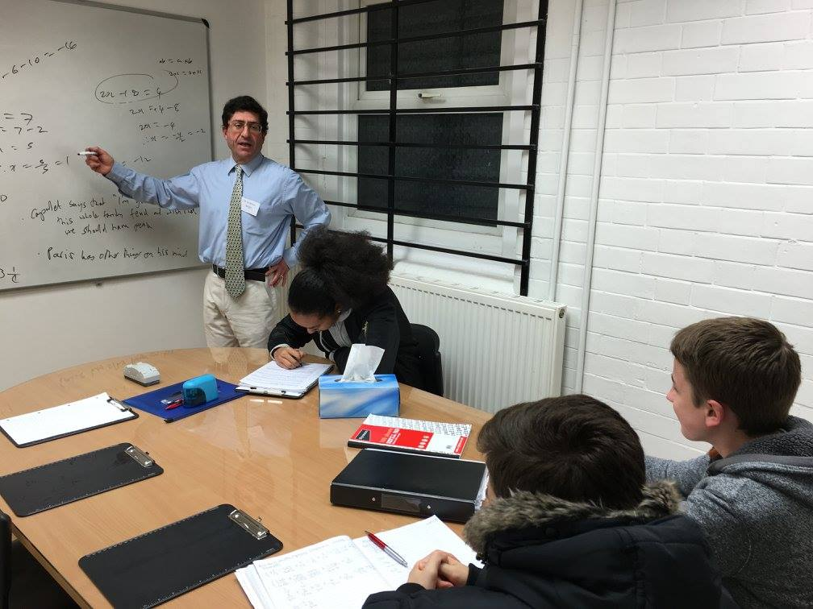
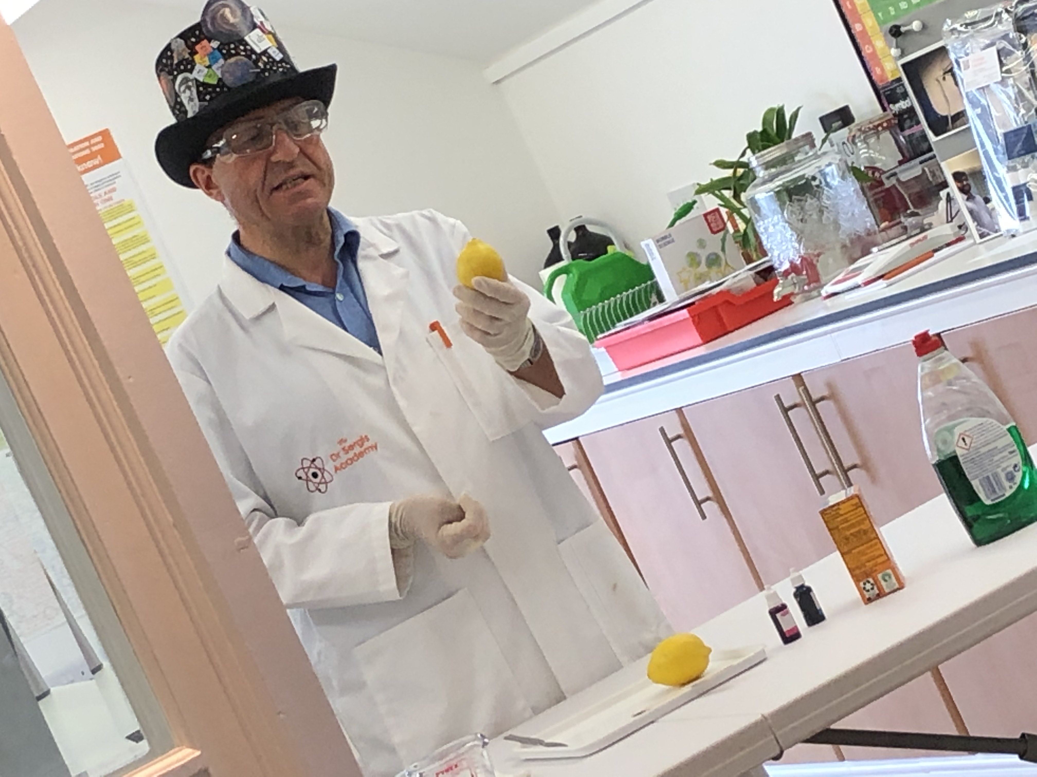
I find that the student gains far more interest in the subject by appreciating the common thread and themes connecting the topics of the subject, rather than memorising a list of apparently separate facts. What appears to be seemingly disparate topics can be linked by a unifying theme or concept. Therefore, I endeavor to teach students to elucidate the common themes between the different topics in science and maths that are traditionally taught separately. In this way, the students gain a more enjoyable and deeper learning experience once they realise and understand that the different topics they study are simply an integral part of the whole subject. I hope you enjoy reading this tenth anniversary bumper issue of our newsletter and I wish you every success in your examinations and future aspirations!

Dr A. N. Sergis
Director and Tutor
2024

1.

What’s new?
In the Spotlight…Dr Chris Fellas

Learn More Online!
Dr Chris Fellas, who sadly passed away on 18th February 2023 at the age of 74, was Dr Sergis’ friend. Dr Fellas, also known as Takis Fellas, was the founder, CEO and Managing Director of Hellenic TV, a digital TV channel broadcasting from studios in North London.
Dr Fellas, a Greek Cypriot, came to London at a young age with a scholarship from Northern Cyprus. He studied at Aston University, Birmingham, Surrey University and Manchester University. He obtained qualifications in BSc in physics with Honours, MSc in Nuclear Reactor Technology and a PhD in physics.
Dr Fellas designed the first Greek satellite for Hellenic TV, which was launched in 1990. Speaking to Cyprus Mail before his death, Dr Fellas recollected: “It was a momentous moment in the history of Greek and Cypriot communities in the UK…I never imagined I would be making history when I launched the satellite and founded Hellenic TV”.
Dr Fellas attended Dr Sergis’ Academy and invited Dr Sergis to give talks on Hellenic TV. Dr Fellas and his broadcaster interviewed Dr Sergis on Hellenic TV on at least eight occasions, before, during and after the outbreak of the coronavirus-19 pandemic, from 2019 to 2022. Dr Sergis was asked to explain the general mechanisms of how viruses transmit infections and, in particular, the origins and spread of the COVID-19 virus and how the general public can help to minimise and prevent infection of this deadly virus.
Dr Sergis is deeply saddened by the loss of Dr Fellas and passes his deepest and heartfelt condolences to his family.

Our social media channels are just brimming with inspirational facts and useful videos! Our YouTube and Tik Tok channels are regularly updated with educational videos on various topics including challenging mathematics past examination questions. Feel free to comment any topics or questions you would like covered! Don’t forget that parents can also keep up to date with any closures on our Facebook and Instagram pages. We also regularly post blogs on our website on various inspirational figures and topics relating to learning and education. Visit our website www.dsacademy.co.uk to start reading!

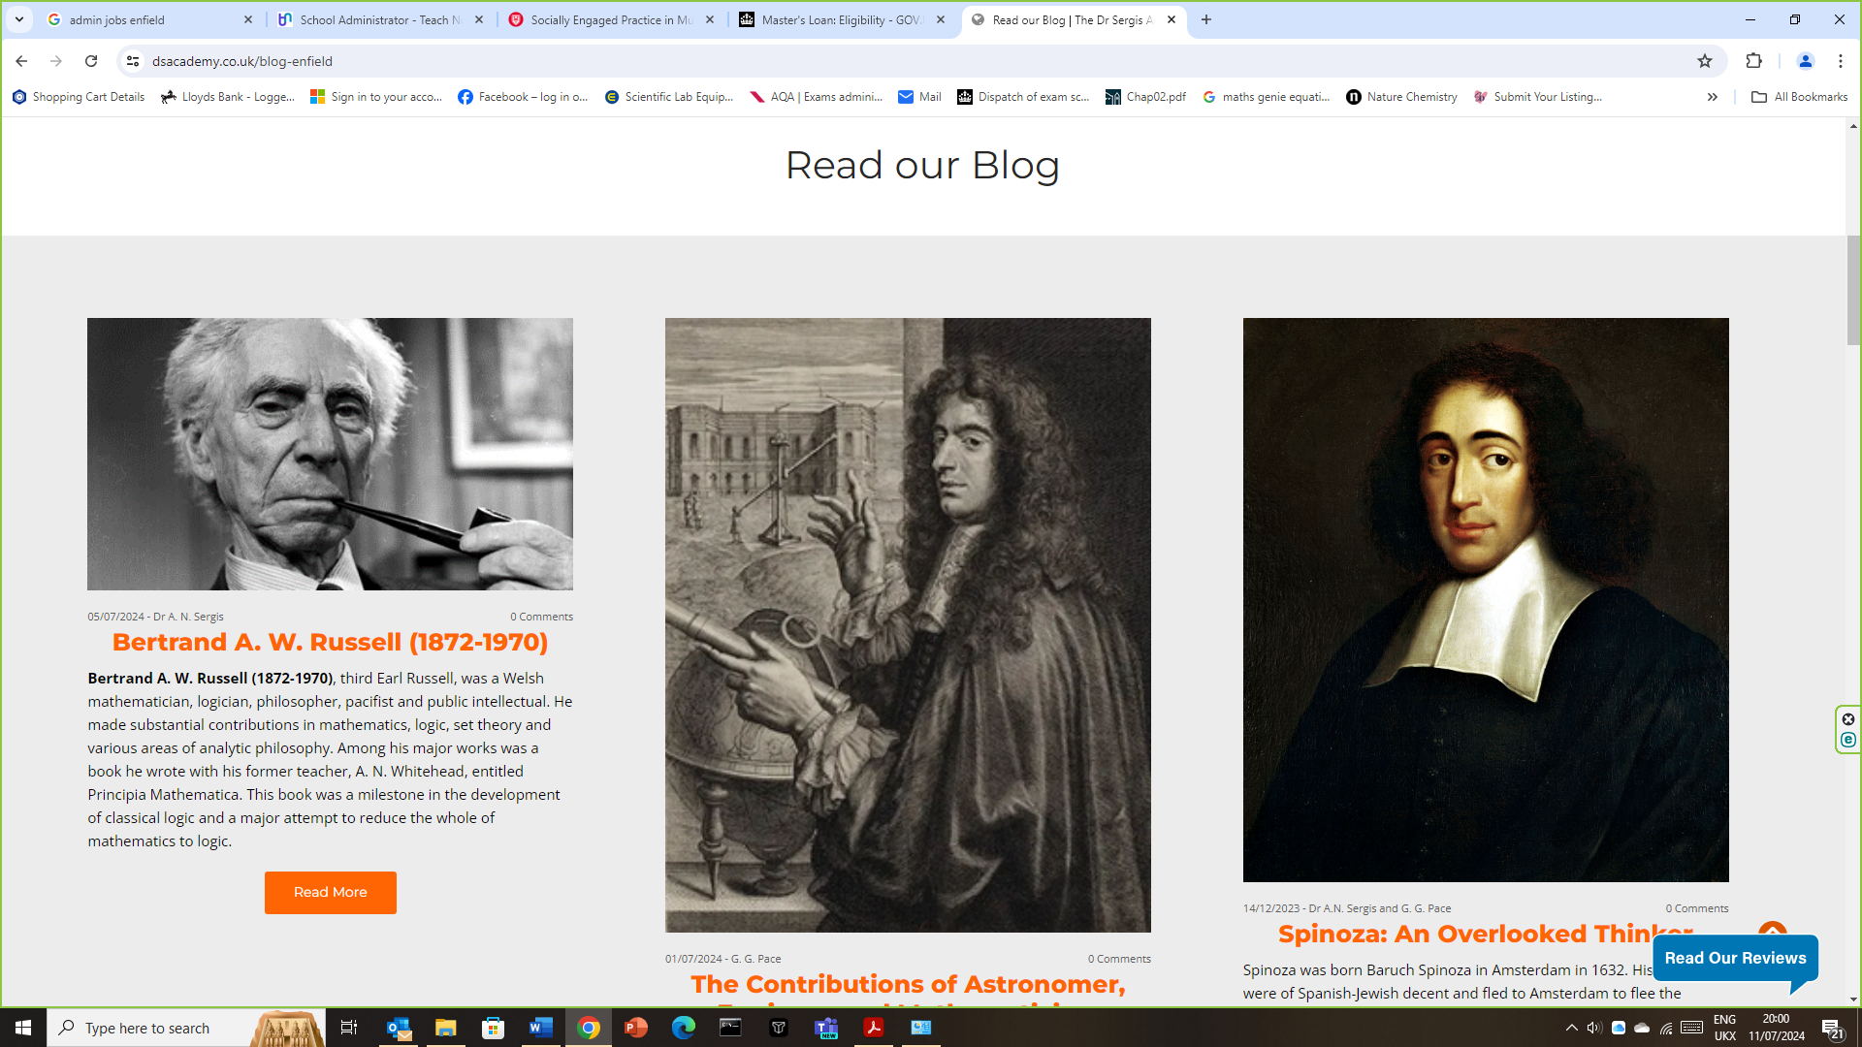
New Teachers at the Academy

We are in the process of recruiting teaching assistants from various colleges in the borough. They will help with English, Maths and Science. The teachers will work alongside Dr Sergis. Watch this space!

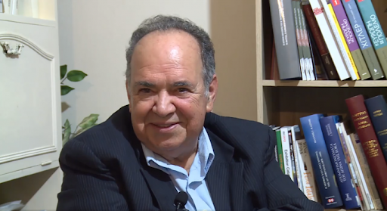
2.

AN INSPIRATIONAL FIGURE: BERTRAnd A. W. Russell (1872-1970)
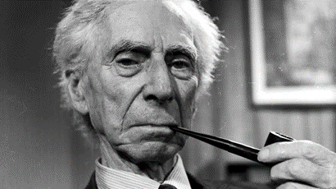
Bertrand A. W. Russell (1872-1970), third Earl Russell, was a Welsh mathematician, logician, philosopher, pacifist and public intellectual. He made substantial contributions in mathematics, logic, set theory and various areas of analytic philosophy. Among his major works was a book he wrote with his former teacher, A. N. Whitehead, entitled Principia Mathematica. This book was a milestone in the development of classical logic and a major attempt to reduce the whole of mathematics to logic.
Bertrand Russell was also an essayist, historian and winner of the 1950 Nobel Prize for literature for championing “humanitarian ideals and freedom of thought”. When Russell was eleven years old, his brother introduced him to the work of the Greek mathematician Euclid, which he described as “one of the greatest events of my life, as dazzling as a first love”. However, his lifelong work in mathematics was matched by his social and political concerns for peace and freedom of speech.
Born to a British aristocratic family, one with highly unorthodox overtones, including an atheist father and a feminist grandmother, he became known for his keen interests in political and social theory. He avidly read and critically studied many classical Greek works, especially all of Plato’s works, including the “Republic”. At various stages in Russell’s life, he considered himself to be a liberal, a socialist and a pacifist. During World War One, Russell was dismissed from Trinity College for his pacifist activities. In 1917, he played a significant role in the “Leeds Convention”, a gathering of a thousand “anti-war socialists”, and was later convicted and imprisoned for publicly protesting the entry of the United Kingdom into the war.
Russell was enthusiastically supported by his fellow faculty members, and this helped to reinstate him at the university in 1919, but he resigned shortly afterwards to devote himself to exploring communism in Russia and China. In 1920, he visited Lenin in Russia and spent an hour with him, and later said he regarded him as a great man who fought for social justice in his country.
In the years before the onset of World War Two, Russell taught the science of power at the London School of Economics, and Philosophy at the University of Chicago and at the University of California, Los Angeles (UCLA). Russell opposed the rearming of Britain against Nazi Germany; however, he concluded that Hitler would be a permanent threat to democracy and by 1943, he declared that war was always a great evil, but in some particularly extreme cases, it may be the lesser of two evils.
By the end of the Second World War, he wrote his famous “History of Western Philosophy”. Furthermore, Russell played a substantial role in diffusing the Cuban Missile Crisis during October of 1962 when Soviet Russia deployed nuclear missiles in Cuba after it feared that the United States would invade Cuba, following the successful revolution by Fidel Castro in 1959, after he overthrew a dictatorship that reigned as the government between 1952 and 1959.
In an attempt to calm the increasing tensions between the United States and Soviet Russia, Russell wrote to Chairman Khrushchev and received assurances from him that Russia would not make reckless decisions in regard to the crisis. Bertrand Russell therefore devoted considerable time and energy to the fight for disarmament and to prevent the possibility of a nuclear war. In later life, Russell was a passionate anti-war advocate and campaigner for global nuclear disarmament. Russell was often involved in mass demonstrations in extreme old age and gained admiration from a new generation of anti-war demonstrators.
Sadly, the British judiciary system took the extraordinary step of sentencing the 89-year-old Russell to a second period of imprisonment. When he died in 1970, Russell was far better known for his anti-war campaigns than as a philosopher of mathematics. However, Russell will be remembered as both a great intellectual thinker and a moral philosopher for the common good of humanity and world peace.
3.

Dr Sergis and einstein at the metro bank event

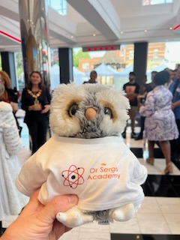

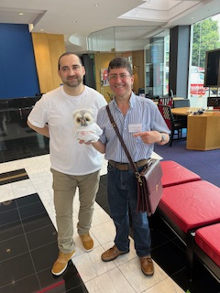
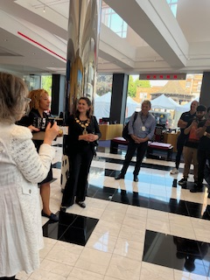
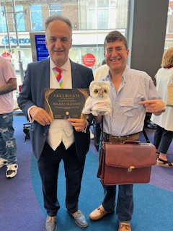
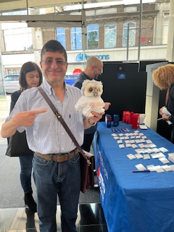

Dr Sergis and Einstein attended a social networking event at Metro bank in Enfield Town. There were many different people from all different businesses across Enfield. The Mayor of Enfield, Cllr Suna Hurman, was also in attendance.

4.

Work experience at the academy
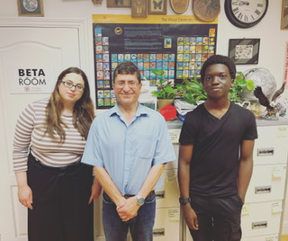

In July of 2023, the Academy welcomed Chidum as our work experience student. Chidum worked alongside Dr Sergis and Gabriella with day-to-day tasks such as filing and photocopying. He also got to prepare and attend a social event at Oasis Academy Enfield, handing out leaflets and goody bags. The Academy welcomes students from across the borough for work experience for both assistant teaching positions and administrative assistant roles.

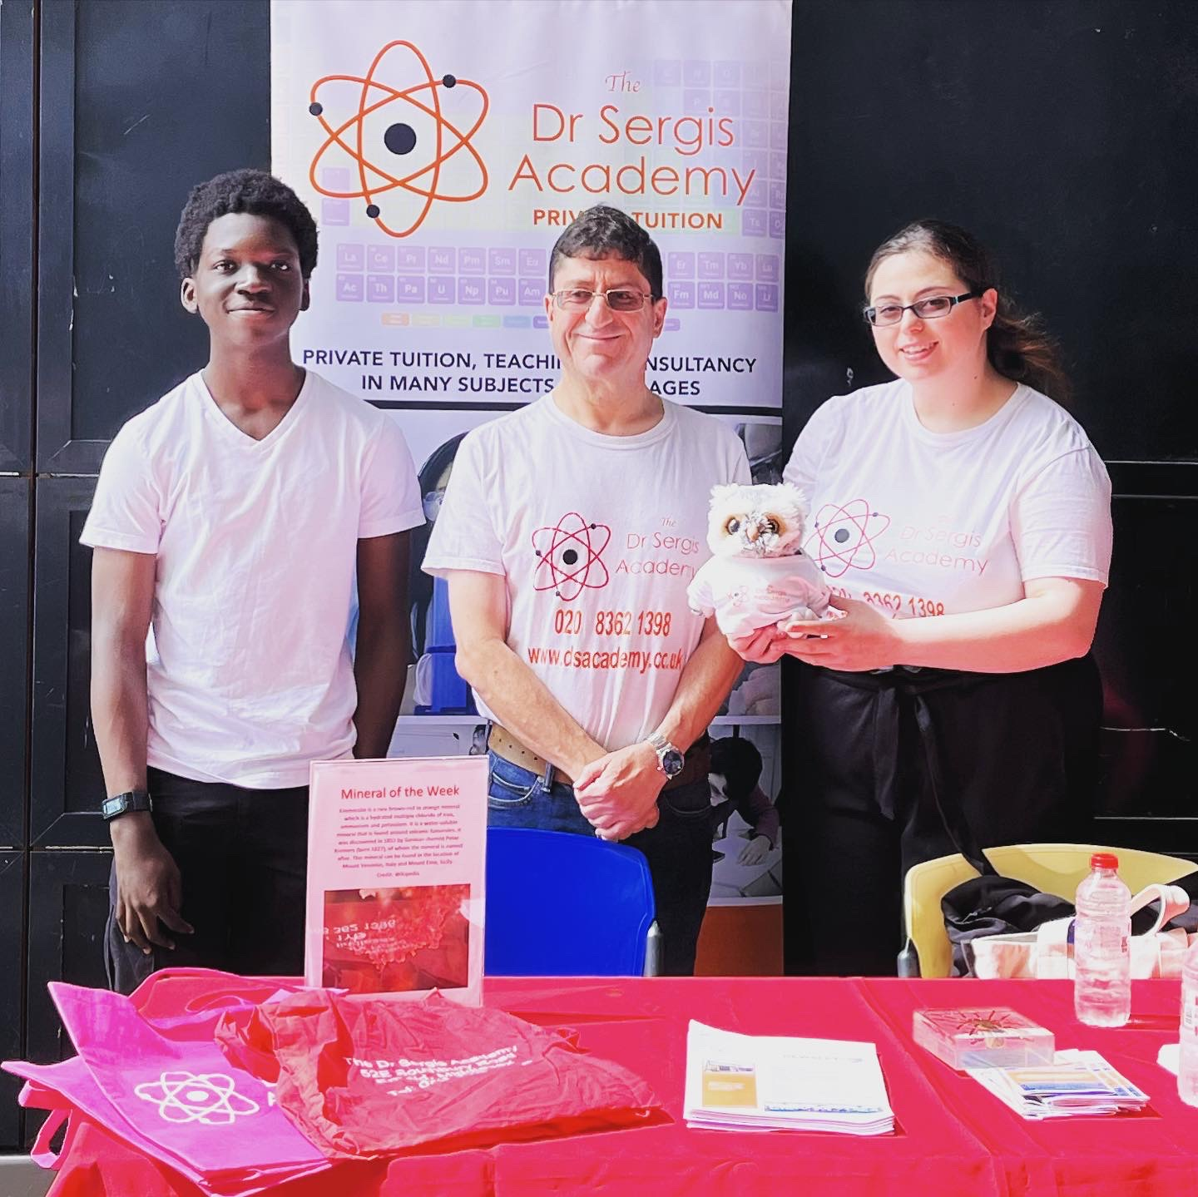

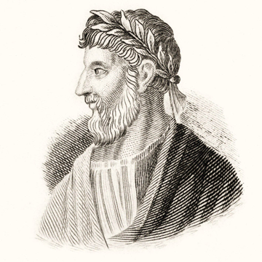
who was Apollonius of perga?
Apollonius of Perga was an ancient Greek mathematician and astronomer (c.240 BC- 190 BC) known for his work on solid geometry and mathematical theorems. Perga was a Hellenized city in Pamphylia, Anatolia (modern Turkey), whose ruins still stand, and was a centre of Hellenistic culture. Apollonius derived the four conic sections that modern mathematicians use: the circle, ellipse, parabola and hyperbola. He achieved this using the section obtained from a plane cutting through two inverted cones. Apollonius defined the definitions of the terms of ellipse, parabola, and hyperbola that we still use today, and he derived a number of other mathematical theorems on plane and solid geometry.
Apollonius was influenced from the earlier work of Euclid and Archimedes and developed the fundamental notions that form the basis of modern analytical geometry. Apollonius also worked on many other topics, including astronomy and mechanics. Most of his works have not survived, but his works have been referenced by other great mathematicians, including Pappus of Alexandria. Furthermore, he developed a hypothesis to explain the motion of planets and is believed to have contributed in other areas of astronomy. Consequently, the Apollonius crater on the Moon was named in his honour. Apollonius is generally considered among the greatest mathematicians of antiquity and modern times.
5.

THe dr sergis academy celebrates ten years!

The Academy celebrated ten years of teaching at our current building last October. Dr Sergis has been teaching for far longer but acquired the current building in 2013. It was a painstaking process to restore the old Edwardian industrial building and it is unrecognisable from what it once was. Dr Sergis had a vision of creating a welcoming learning environment that had a fully equipped science laboratory. With a team of dedicated contractors, it took just one year to complete. Today, it is a friendly, warm and quiet space to work in.

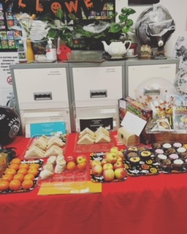
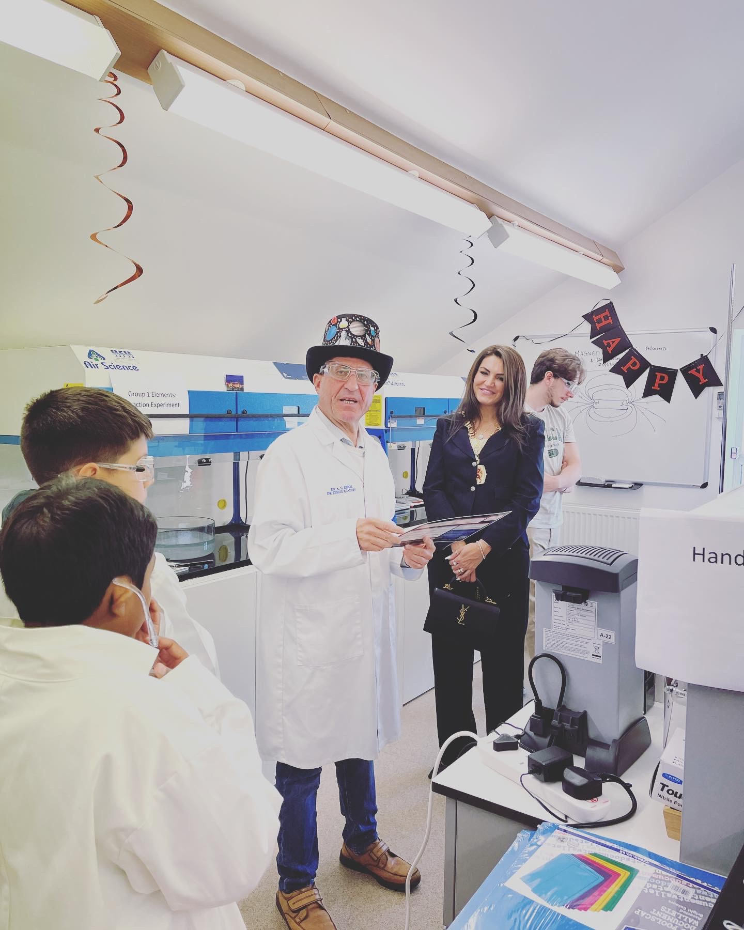
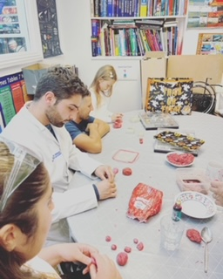
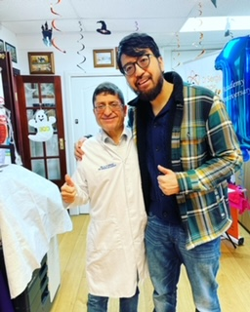


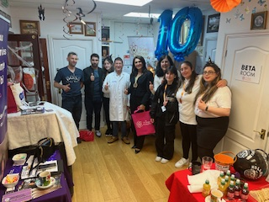
On the day, there were fun and creative workshops in the classrooms as well as a range of science experiments in the laboratory. The event also attracted the attention of the current Mayor of Enfield, Cllr Suna Hurman. Goody bags were available on the day for each guest which included information about the academy and small gifts. There was also a tasty buffet with sandwiches, wraps and cakes freshly prepared from the local Sainsbury’s. The Academy was also decorated with a spooky Halloween theme. There were also some stall holders on the day showcasing their services, including Pamela and David from Utility Warehouse (pictured below). We are very proud of our building, and it is the centre of operations for the business.



6.


Owls in the ancient world
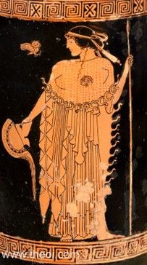
Ever wondered why we picked an owl to be our mascot? Well, in the ancient Greek world, owls were a symbol of wisdom. The owl became the favoured animal of Athena, goddess of wisdom and became her symbol. Athena’s ‘little owl’ symbol was often used to protect finance and is often represented on coinage.
These birds were not only a symbol of knowledge and they have been interpreted differently in many cultures. Owls have been depicted in the Libyan Palette, which shows a settlement represented by an owl figure. In old English tales, the owl, more specifically the Barn Owl (Tyto alba), was regarded as a symbol of doom or death. These owls were also thought to predict the weather and a screeching owl meant a storm was on the way. Owl eggs were used for medicinal purposes in a variety of ways to treat many illnesses. This was also a belief shared by the ancient Romans.
In Hinduism, the goddess of wealth and prosperity Lakshmi, is shown with a white barn owl. In Native American culture, the owl was linked to prophecy and in some tribes, it represented the god of death. In Africa, owls were usually associated with magic and were also believed to be messengers of the dead. In ancient Egypt, they were associated with hunting and hunting prowess but also with death. The figure of the owl is imbued with magic and superstition and its nocturnal nature is no doubt the source of so many of the myths. Owls represented many different things to many cultures throughout time and this article has only touched upon a few. We are not sure if Einstein our mascot has any prophetic powers and if he does, he is sure keeping them quiet!

Plato’s academy
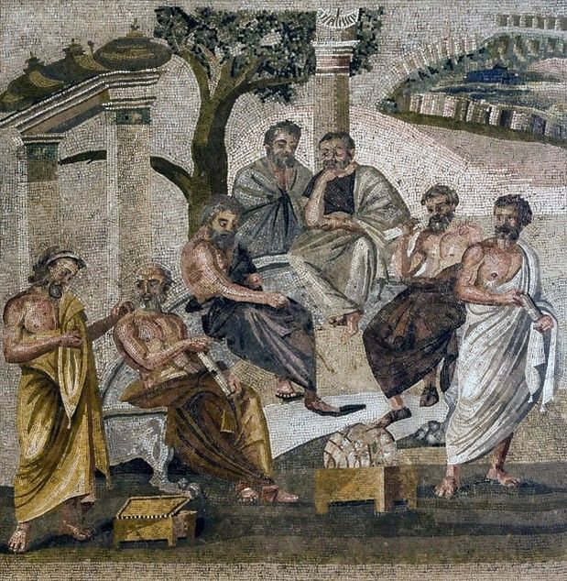
Founded in 387 BC by Greek philosopher Plato, the Academy was situated just outside the city of Athens, outside of the city walls. Before the actual building was built, intellectual gatherings were held in a garden area surrounded by sculptures, olive trees and lined with temples. This area was often used for recreation and group meetings and activities. When Plato bought the land, he began to hold casual meetings with other thinkers long before the Academy building itself was ever built. Considered the first ever university in the world, it was not exactly like a school or university today as it was not as structured, but its attendees could discuss many subjects including philosophy, astronomy, mathematics, politics, and physics. Aristotle was a student at the Academy, and he would later go onto found his own Academy, the Lyceum also in Athens. Plato taught using a combination of lectures and seminars as well as a method involving a dialogue between teacher and student, which is something Dr Sergis has adopted in his own teaching in his own academy. During Plato’s times, entrance to the Academy was free. Following Plato’s death in 348/7 BC at the age of 81, his nephew Speusippus succeeded the Academy as head. The Academy continued its operation for nearly 200 years after Plato’s death, even after the Roman general Lucius Cornelius Sulla, conquered Athens and destroyed the Academy by fire in 86 BC. During the late Roman period, the Christian Roman Emperor Justinian, I closed it once and for all in 529 AD. Despite the destruction of the building, Plato’s philosophy survived and has lived on to influence the ages. It was reborn in Neoplatonism and sparked off the Renaissance. It has been fundamental in the development of Western philosophy and theoretical physics in the modern world.
7.

The dr sergis academy returns to the annual laboratory exhibition

The latest visit to the laboratory exhibition in Birmingham of last year proved to be a success. Dr Sergis was able to purchase a rotary evaporator for the laboratory to use for his scientific research from one of the companies in attendance. The rotary evaporator is an important laboratory apparatus for removing solvents during the synthesis of organic compounds and is used in both universities and industrial laboratories. The exhibition is the place to visit for all the latest scientific pioneering technology and research as well as the place to find services and make business and industry connections. As always, we made many new connections and have lots of services to refer to for all our scientific laboratory needs.

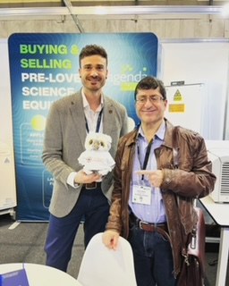

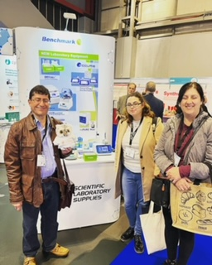



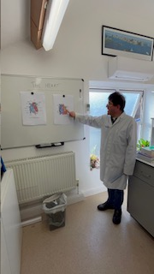
8.
Dr Sergis dissected an ox’s heart in front of students in the Academy lab. It was started with a quick lecture on the heart and then the demonstration began. Students were also allowed to touch the heart and investigate it for themselves whilst wearing gloves and lab coats. Students can arrange to do experiments in the lab as per the curriculum/exam board if they so wish. This experiment was free, but more elaborate experiments may incur a small set up fee.

HEART EXPERIMENT IN THE ACADEMY LABORATORY


the academy attends a greek night in sue’s name



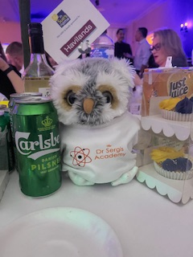

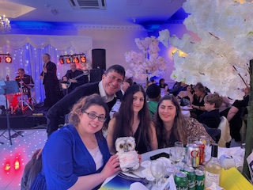
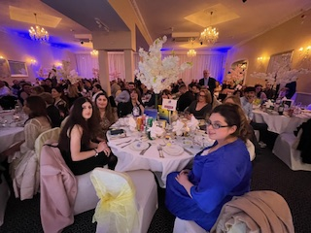

In March 2024, the Academy attended a Greek night at the Penridge Suite in London. The night helped to raise money for the charity In Sue’s Name, a charity with whom we have worked to raise money for in the past and it is one that is dear to us. In Sue’s Name was founded in 2014 by David Taylor in memory of his beloved daughter Sue Blasotta, who died in 2011 of brain tumours. The event held a raffle of luxury prizes and guests were treated to a delicious three course meal. Einstein the lucky mascot was in attendance as well as daughters of Dr Sergis, Andrea and Sophia, and receptionist Gabriella. The night was complete with lovely Greek music.
Dr Sergis with David Taylor, father of Sue and founder of the charity
Did you know?
- Approximately 45 people each day in the UK face a brain tumour diagnosis
- Over 100,000 people in the UK are living with a brain tumour
- There are more than 120 different types of brain tumours making them notoriously difficult to diagnose
- The cause of brain tumours is not known, they can affect anyone regardless of age, sex, lifestyle or general health
- Brain tumours kill more children and adults under the age of 40 than any other type of cancer
- Incidences of, and deaths from, brain tumours are increasing
From braintumoursupport.co.uk

9.

catherine the great of russia and education reform
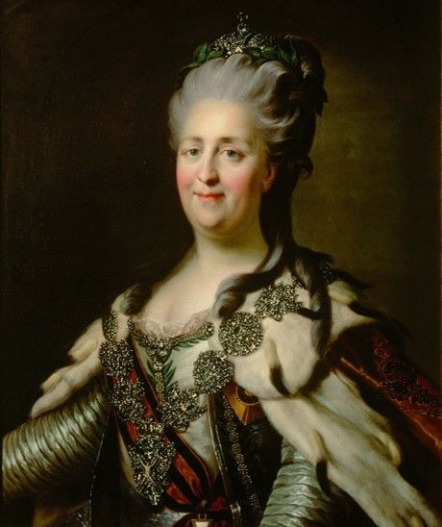
Catherine the Great is one of the most interesting female figures in history. She led an eventful but fruitful life, and she was a strong advocate for Enlightenment thinking. In this blog article, we take a look at her studious character and her influence on the educational reforms of Russia. During her unhappy marriage to Peter III, Catherine passed the time reading. She was particularly interested in works on political philosophy, literature, and history. She devoured the works of thinkers such as Plato and Voltaire, which is how she became introduced to the French Enlightenment.
Throughout her reign, Catherine collected a vast array of art pieces by many famous European artists, which, at the time of her death, amounted to some 4,000 pieces. The collection is now housed at the Hermitage Museum in Saint Petersburg, once the Winter Palace. She was often depicted as Minerva, the Roman goddess of wisdom, the arts, and strategy in war (equivalent to the Greek goddess Athena). Her court became the epicentre of cultural life in Russia in the late eighteenth century. A native of Prussia (in an area now part of Poland), she dedicated herself to learning the Russian language. After a coup to depose her husband, Catherine declared that she would do her best to help her people, vowing to serve them with goodness and care.
She vowed to turn Russia’s people into citizens through the improvement of laws and education and she built hospitals and schools. Scholarships to foreign countries were paid for by the state and she made sure there was a secondary school in every province. Above all, she made sure that these schools offered a secular education and one that was not influenced by the church. The schools offered a well-rounded education, with the focus on mathematics, science, history, geography and languages. In 1764, the Moscow Orphanage, also known as the Foundling Home, was established, and offered to help educate the very poor. Catherine also believed that women should have the same access to education as men, however, the opportunity was not available to absolutely every woman.
One of the first schools she established was the Smolny Institute for Noble Girls (or Maidens) in Saint Petersburg (pictured right), founded in 1764. This school was only open to girls of noble birth, and they were taught singing, painting, and science. Women of low birth, Catherine thought, should be taught differently from those of higher birth. To her, education was not a means to improve one’s station, but to create model citizens of the station they were born into. This way, the whole population was to be well educated at every level, and willing to serve their state. This is of course, very different to how we view education today.
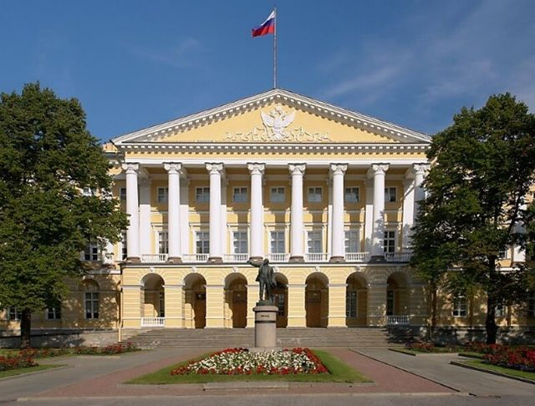
Catherine the Great was a forward-thinking monarch and attempted to change attitudes towards education in her adopted country. Although her reforms are seen as very limited by today’s standards, they were revolutionary for her time, and they were nevertheless created with good intentions. Her artistic interest and patronage have left its mark on Russia, and many beautiful neoclassical buildings still stand today.

10.

Picture perfect
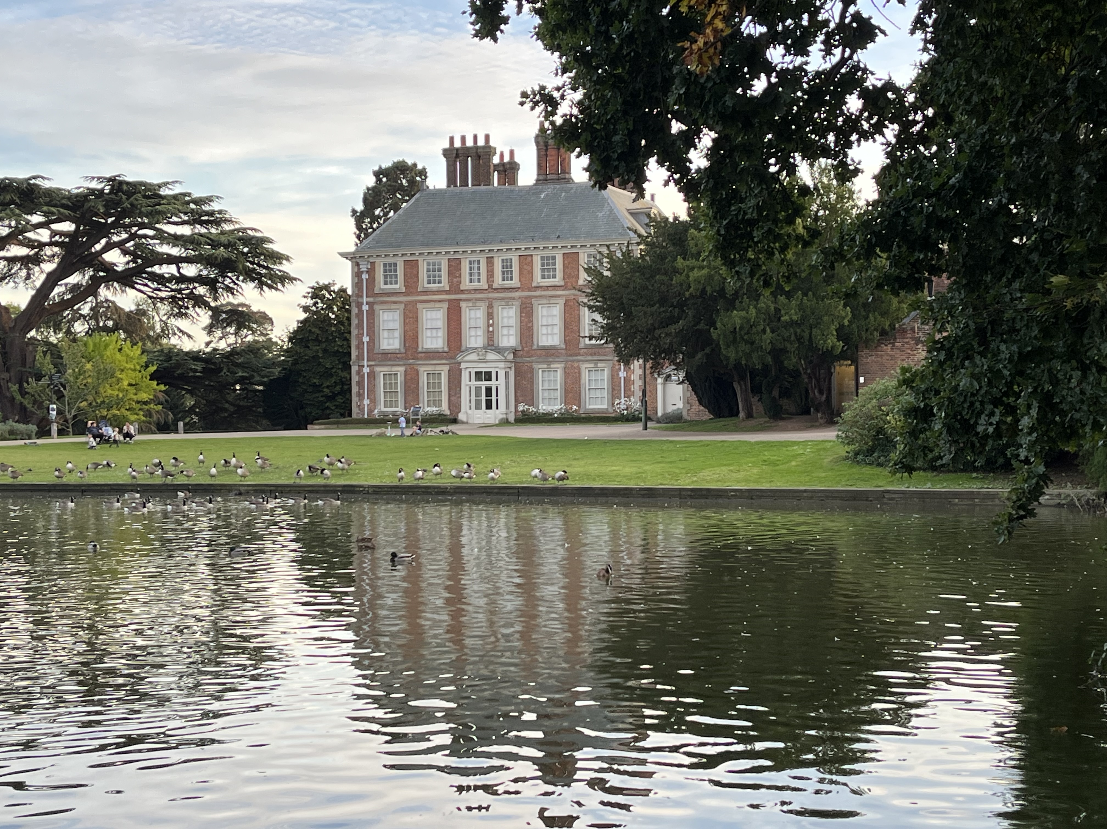
A picture of Forty Hall captured by Dr Sergis in October 2023
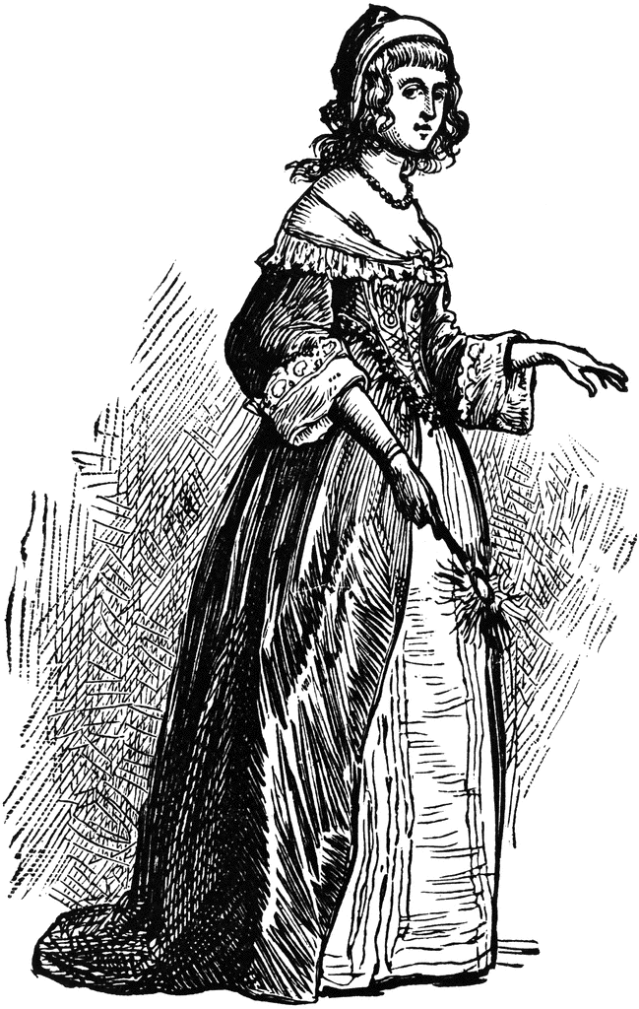
11.
Did you know?
- The hall is the Architectural gap between Medieval Manor and Stately home.
- It was built for Sir Nicholas Rainton, Lord Mayor of London and President of St. Bartholomew’s Hospital. He was imprisoned by Charles I.
- Original decorative ceilings and panelling in many of the rooms.
- Original 18th Century plasterwork in the reception room.
Source: www.fortyhallestate.co.uk

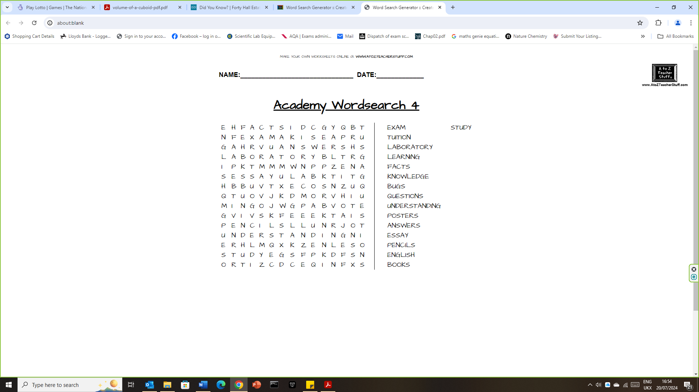
Puzzle page
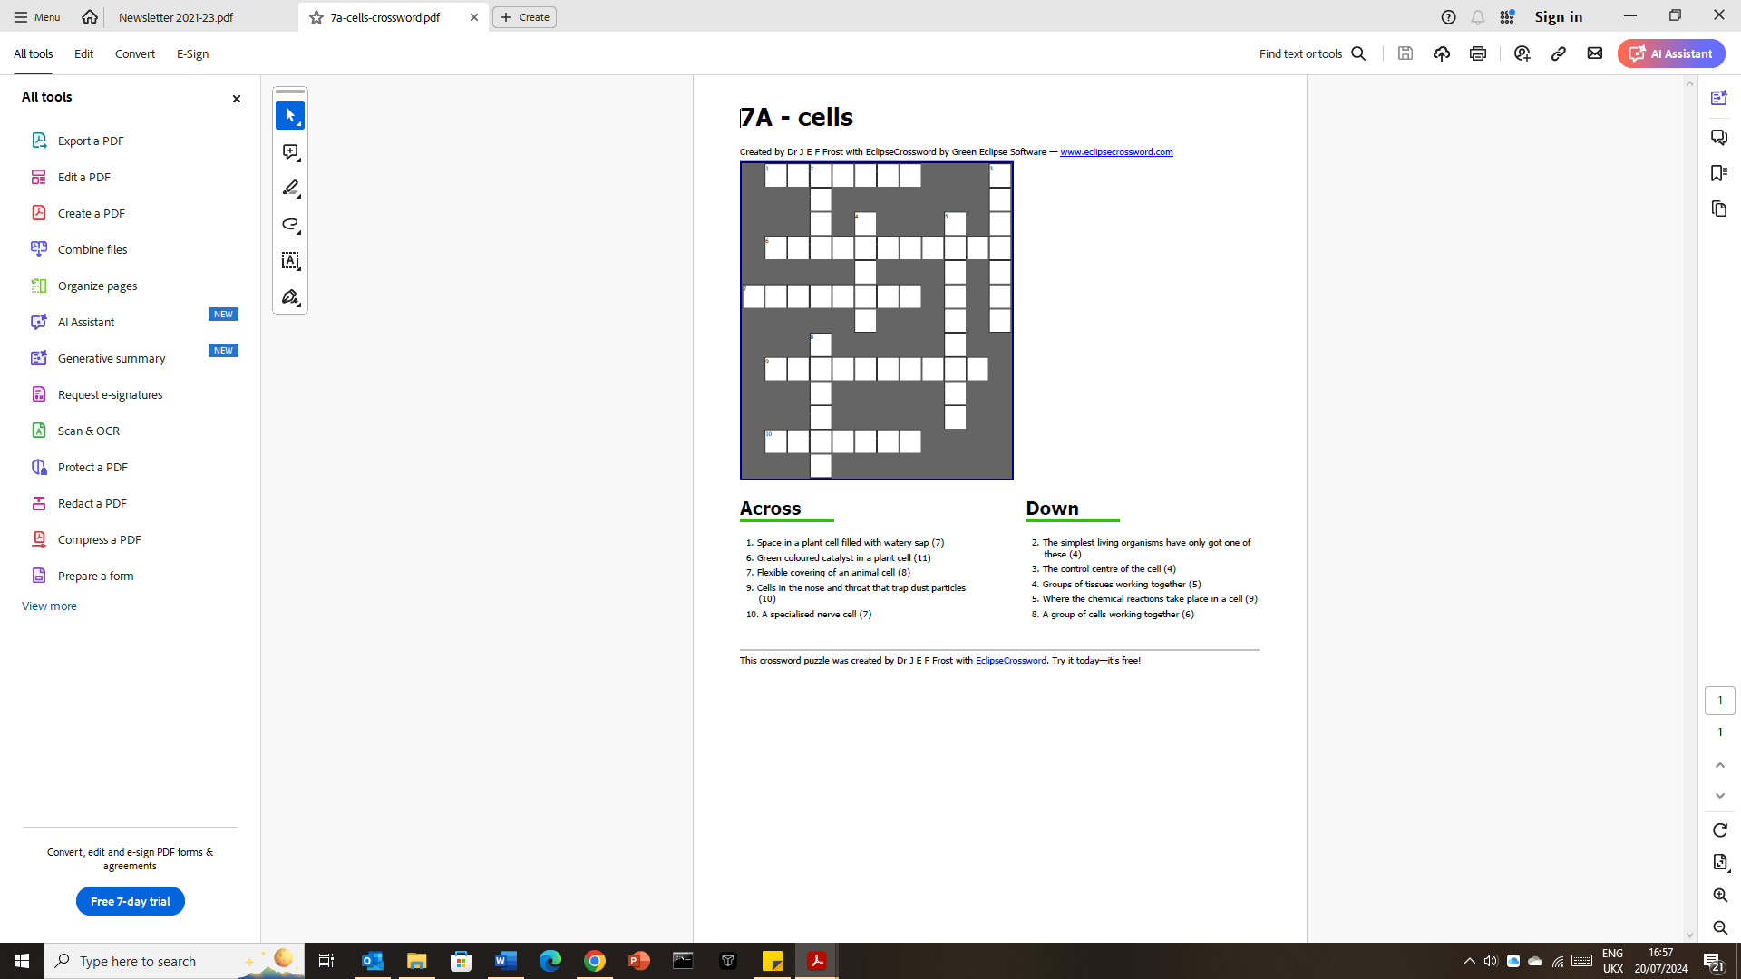
12.

